Circles X

- Find the length of the tangent drawn from a point whose distance from the centre of a circle is 25cm. Radius is 7cm.
- 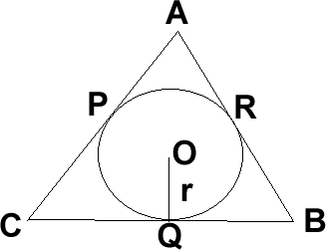ABC, Side AB, BC and CA of triangle touch a circle with centre o and radius r at P, Q and R respectively. Prove that Ar of ABC = $\frac{1}{2}$ (Perimeter of ABC) x r
- Prove that a parallelogram circumscribing a circle is a rhombus.
- 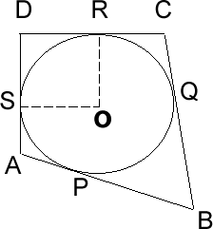 ABCD is a quadrilateral such that D = 90° A circle touches the sides AB, BC, CD and DA at P, Q, R, S respectively. If BC = 38cm, CD = 25cm. BP = 27cm find r.
- 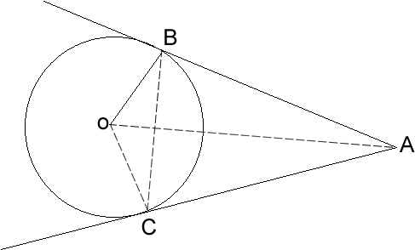Two tangents AB and AC are drawn to a circle with centre O from an external point T. Prove that BAC = 2 LOBC.
- 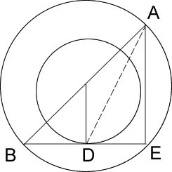The radii of two concentric circles are 13cm and 8cm. AB is a diameter of the bigger circle. BD is a tangent to the smaller circle touching at D. find AD.
- 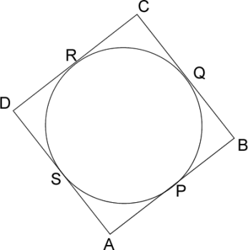A circle touches all the four sides of a quadrilateral ABCD with AB= 6cm, BC = 7cm, CD = 4cm. Find AD.
- If PA and PB are tangents from an outside point P. such that PA = 10cm and APB = 60⁰. Find the length of chord AB
- Find PRS 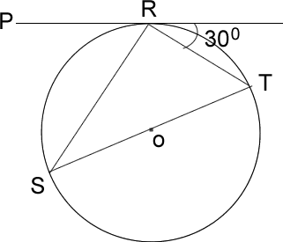
- 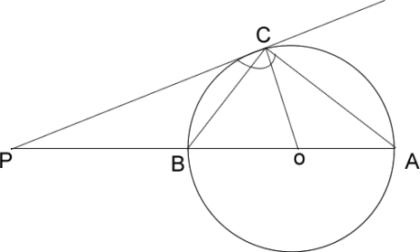 PCA =110° Find CBA

